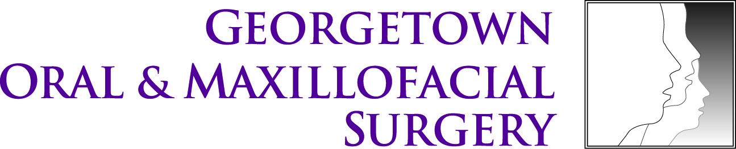
Dr. Richard Williams DDS
Dr. Kenneth Goldblatt DDS
Dr. Kalpakam Shastri DDS
Dr. Ronald Brown DDS MS
“Oral surgery with your comfort in mind.”
4400 Jenifer St. NW.
Suite #270
Washington, D.C 20015
P: 202-364-9400 F: 202-364-1511
www.georgetownoralsurgery.com

Pre-Surgery Checklist

The following is provided as reminders and to review what was presented at your initial consult appointment. If you have any question at any time please call us so we can address your concerns in detail. “Quality starts with caring” has been out motto for years and we will continue to try to make this experience as positive as possible.
Preparing for your surgery visit: Pre-Operative instructions
- Consent- If the patient is under the age of 18, a parent or legal guardian must be present. If a patient does not have medical legal powers over themselves, the legal guardian must be present.

- Diet- If you are to be sedated (intravenous sedation or general anesthetic) for your surgery, DO NOT eat or drink anything for at least 6 hours prior to your surgery appointment. If you take any morning medications, you may have a sip of water with your pills.

- Medications- Please take your regularly prescribed medications unless directed not to by your oral surgeon or your physician. If you are being sedated you can take a small sip of water with your medications prior to surgery. If you use a inhaler for any reason please bring it with you. If you take blood pressure medication, please take as directed. Please ask if there are any doubts about which medications you should or should not take.

- Transportation- If you are being sedated for your surgery or if your procedure is extensive you must arrange to have a responsible adult bring you to your surgery as well as take your home afterwards. This is for your safety.

- Personal Items- Please remove contact lenses prior to your surgery. Please remove all jewelry, including piercings (especially oral ones). Please also remove dental appliances such as partials, dentures and retainers.

- Food- You may want to buy soft foods such as Jell-O, Ice cream, pudding, eggs, yogurt, soft cereals (such as oatmeal), mashed potatoes or pasta. You do want to eat after surgery, but foods should not be above room temperature and need to be soft. To prevent nausea, begin with clear fluids such as water, Classic Coca-Cola, ginger ale or Sprite. Advance your diet as you feel up to it. It is very important to drink plenty of water after your surgery.

- Payment- Payment is due at the time of surgery. We will make every attempt to work with your insurance company and are happy to provide you with your estimated costs prior to your surgery.

If you have any questions or concerns please call us prior to your appointment so we have time to address your concerns.

